- \Operation\Basic settings\Special discharge
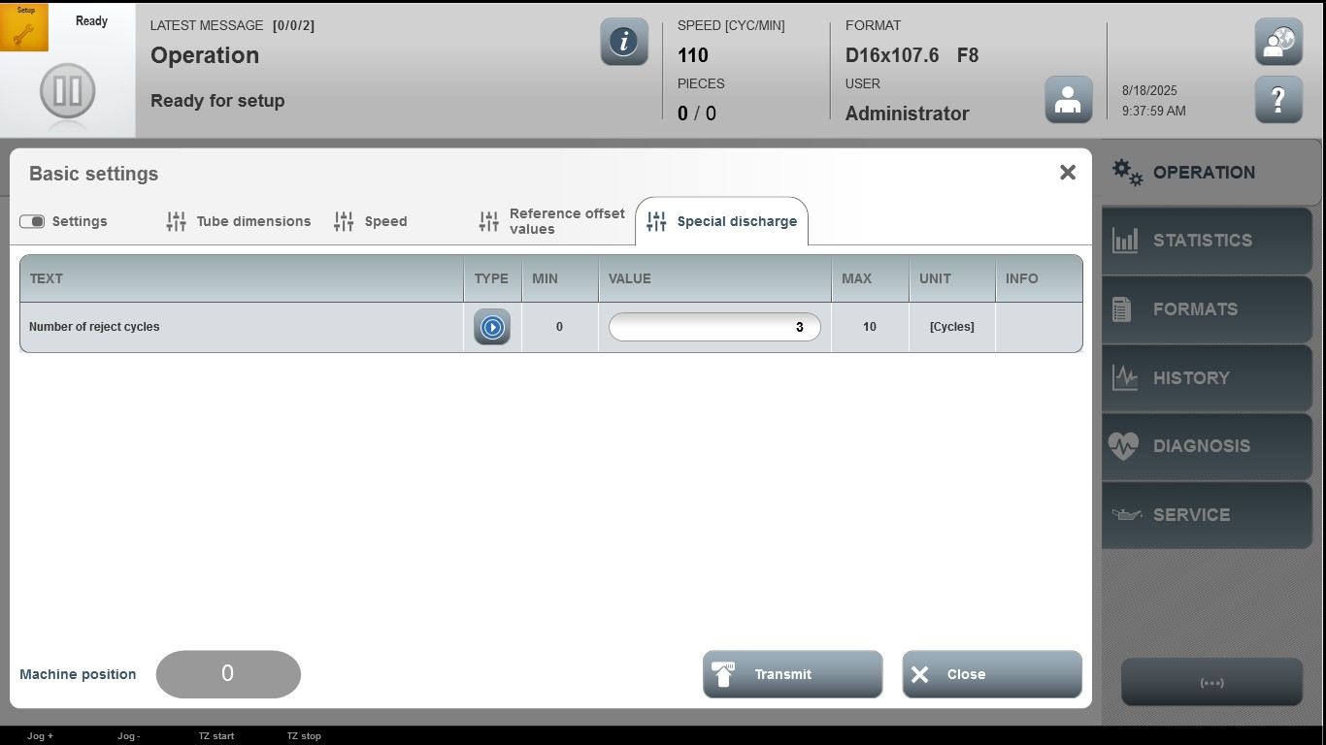

Acceptance criterion | Limits | Pass / Fail: Dev-No. | Date | Initials
Number of reject cycle | 0…10

